December 10th, 2019

Subject: 2020 Frederick County American Little League Sponsorship Program
Attachments: 2020 Frederick County American Little League Sponsorship Levels

Dear Sir or Madam:
Baseball season is just around the corner. It’s time for Frederick County American Little League (FCALL) to prepare for the 2020 Little League season. As you may be aware, a major part of the preparation is our Sponsorship Program; which is critical in ensuring that our program is affordable to our entire community.

FCALL is a Williamsport affiliated Little League and is entirely volunteer based. FCALL receives no financial support from the local county or city. Financial support is generated in the community in the form of FCALL Registration Fees, our Fundraising Program, and our Sponsorship Program. Due to the recent economy, we have had several families in need of financial assistance. Part of your donations will help ensure that their child(ren) is able to play in the 2020 season. To help you decide on the 2020 sponsorship level that best suits your organization, FCALL has compiled the following facts, data, and estimates for your consideration:

• The FCALL Board of Directors is estimating that the league will again have approximately 400 boys and girls, ages 4 to 16.
• Εach child, along with his/her parents/guardian, will be at the fields available to FCALL an average of three (3) times per week from March through June for practices and games. All-Stars will begin Mid-June thru August.
• FCALL is co-sponsored by Frederick County Parks & Recreation.
• Your generous donations to FCALL are tax deductible.

More than ever, our Sponsorship Program shall be a strong element in the ongoing and future success of our organization.

FCALL respectfully requests that your organization consider becoming a part of the FCALL family by selecting the “Sponsorship Level” that best suits your organization’s goals and objectives. Simply complete and return the attached “Sponsorship Form” to our address as noted above. To allow enough time for uniform procurement, we request your response on or before February 15, 2020.

On behalf of the children and the entire FCALL family, I would like to thank you in advance for your support. Should you have any questions about the 2020 FCALL Sponsorship Program, please feel free to contact Chris Pownell via email at fundraising@fcall.org.

Sincerely,
Frederick County American Little League

Chris Pownell
FCALL Fundraiser/Sponsorship Coordinator

When you sponsor a Frederick County American Little League team here is what we will do for you:
- Business Name on the back of your team’s jersey’s.
- Business Name and logo on a large banner that will hang on the concession stand building at the Stonewall Park Complex.
- Business name will be associated with the team on the schedule & website. (i.e. Autobody Suppliers Orioles or Shirley Well Drilling Hurricanes)
- Business name and contact information will be listed on the FCALL website under sponsors.
- Business name and contact information will be distributed out to all the players in their first of year information packet.
- Team photo plaque for you to hang with pride in your business.
- We are open to any advertisement ideas. (i.e. 10% off if you come in wearing your FCALL uniform or player of the game coupons)

Contact:
Chris Pownell – fundraising@fcall.org
FCALL Fundraiser/Sponsorship Coordinator

Company/Civic Group Name: ____________________________________________________________
Address: _____________________________City: ________________State: ________Zip: ___________
Contact Person: ____________________________Phone Number: (_____) ________________________
Web Address: ____________________________________ Email: _______________________________
If you sponsor a team your money will be used to provide all players in all division’s hats, shirt, plus a shirt and hat for our managers and coaches. Your donation also covers the participation fee per child to Little League, plus league insurance. In addition, for your generous investment, your business name will be used to identify the team on their jerseys and the website. Your business logo will be placed on a large banner that will recognize and honor all our sponsors. You will also receive a team photo plaque at the end of the season to display in your business.
If you sponsor the Game Balls for a division or a Player Scholarship your business name will be placed on the large banner that will recognize and honor all our sponsors and your business logo will be placed on the website.
Divisions: (Please √ all that apply)
Home Run:
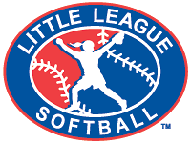
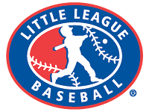
Major, 50/70, Junior or Senior Division
Baseball or Softball $450.00 ____

Triple:
Minor Division
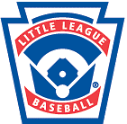
Baseball or Softball: $350.00 ____
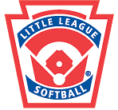
Double:
Tee-Ball or Coach Pitch Division
Baseball or Softball: $275.00 ____

Single:
Game Balls or Player Scholarship: $100 _____

Please remit form and check made payable to:
F.C.A.L.L., P.O. Box 2412, Winchester, VA 22604
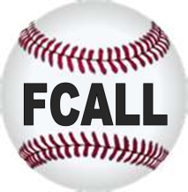
Contact Chris Pownell – fundraising@fcall.org for further questions.

Thank you for supporting
Frederick County American Little League

